

**Name:** Chandana Ramesh Galgali

**Batch:** P6-1 **Roll No.:** 16010422234

**Date:** 17 March 2023

**Experiment No. 03**

**Title**: Spectrophotometry

**Aim**: To find out the unknown concentration of the sample.

**Theory:**

A spectrophotometer is a photometer that can measure the intensity of light as a function of its wavelength. Single beam and double beam are the two major classes of spectrophotometers. Linear range of absorption and spectral bandwidth measurement are the important features of spectrophotometers.

In Single Beam Spectrophotometers, all the light passes through the sample. To measure the intensity of the incident light the sample must be removed so that all the light can pass through. This type of spectrometer is usually less expensive and less complicated. The single beam instruments are optically simpler and more compact, znc can also have a larger dynamic range.

In a Double Beam Spectrophotometer, before it reaches the sample, the light source is split into two separate beams. One beam passes through the sample and the  second one is used for reference. This gives an advantage because the reference reading and sample reading can take place at the same time.

In transmission measurements, the spectrophotometer quantitatively compares the amount of light passing through the reference and test sample. For reflectance, it compares the amount of light reflecting from the test and reference sample solutions.

Many spectrophotometers must be calibrated before they start to analyse the sample and the procedure for calibrating spectrophotometer is known as "zeroing". Calibration is done by using the reference substance, and the absorbencies of all other substances are measured relative to the reference substance. % transmissivity (the amount of light transmitted through the substance relative to the initial substance) is displayed on the spectrophotometer.

The major sequence of events in spectrophotometry is as follows:

1. The light source shines through a monochromator.
2. An output wavelength is selected and beamed at the sample.
3. A fraction of the monochromatic light is transmitted through the sample and to the photo-detector.

**Single Beam Spectrophotometer:**

 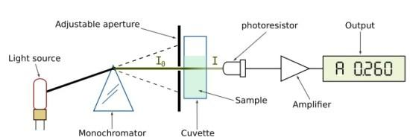

Spectrophotometry deals with visible light, near UV and near IR. To acquire the spectral information quicker in IR spectrophotometers, which use a Fourier transform technique and is called Fourier Transform Infrared (FTIR).

## **Materials Required:**

1. Spectrophotometer
2. Cuvette
3. Blank solution

## **Reagents:**

1. Cobalt (II) chloride
2. Hexaaquacobalt (II) ion
3. Ferrocene
4. Crystal violet
5. Rose bengal
6. Coumarin

**Procedure:**

**Determination of Molar Absorption Coefficient:**

1. Select a blank cuvette and place it in the spectrophotometer. Close the lid.
2. Click on 0 ABS 100%T button, the instrument now reads 0.00000 A.
3. Choose a solution with known concentration and measure the absorbance between the wavelengths 350 nm to 700 nm.
4. Record the wavelength at the maximum absorbance value.
5. Calculate the value of  molar absorption coefficient , using the equation:

**Determination of Unknown Concentration:**

1. Set the wavelength to the value corresponding to maximum absorbance (recorded above).
2. Place the cuvette with the same solution but at an unknown concentration.
3. Read the absorbance for this wavelength.
4. Calculate the concentration with the help of the equation, molarity
5. Enter the calculated concentration value in the given box. (Note : Should enter the value correct to four decimal places)
6. Repeat the same procedure for a second solution.

**Observation:**

**Table-1**

| **S. No.** | **Reagent** | **Concentration**  **(in M)** | **Absorbance** | **λmax**  **(in nm)** |
| --- | --- | --- | --- | --- |
| **1** | Cobalt (II) Chloride | 0.001 | 0.1661 | 510 |
| **2** | Hexaaquacobalt(II) ion | 0.001 | 0.1012 | 510 |
| **3** | Ferrocene | 0.001 | 0.3023 | 445 |
| **4** | Crystal Violet | 0.001 | 0.2569 | 590 |
| **5** | Rose Bengal | 0.001 | 0.2382 | 560 |
| **6** | Coumarin | 0.001 | 0.3008 | 445 |

**Table-2**

**Reagent =** Cobalt (II) Chloride **λmax =** 510 nm

**Path length =** 1 cm

| **Sample No.** | **Concentration**  **(in M)** | **Absorbance** | **ε** |
| --- | --- | --- | --- |
| 1 | 0.001 | 0.1661 | 166.1 |
| 2 | 0.002 | 0.3322 | 166.1 |
| 3 | 0.003 | 0.4983 | 166.1 |
| 4 | 0.004 | 0.6644 | 166.1 |
| 5 | 0.005 | 0.8305 | 166.1 |
| 6 | 0.006 | 0.9966 | 166.1 |
| **Unknown** | 0.0819 | 13.6036 | 166.1 |

**Average =** 166.1

**Screenshots of the simulation:**

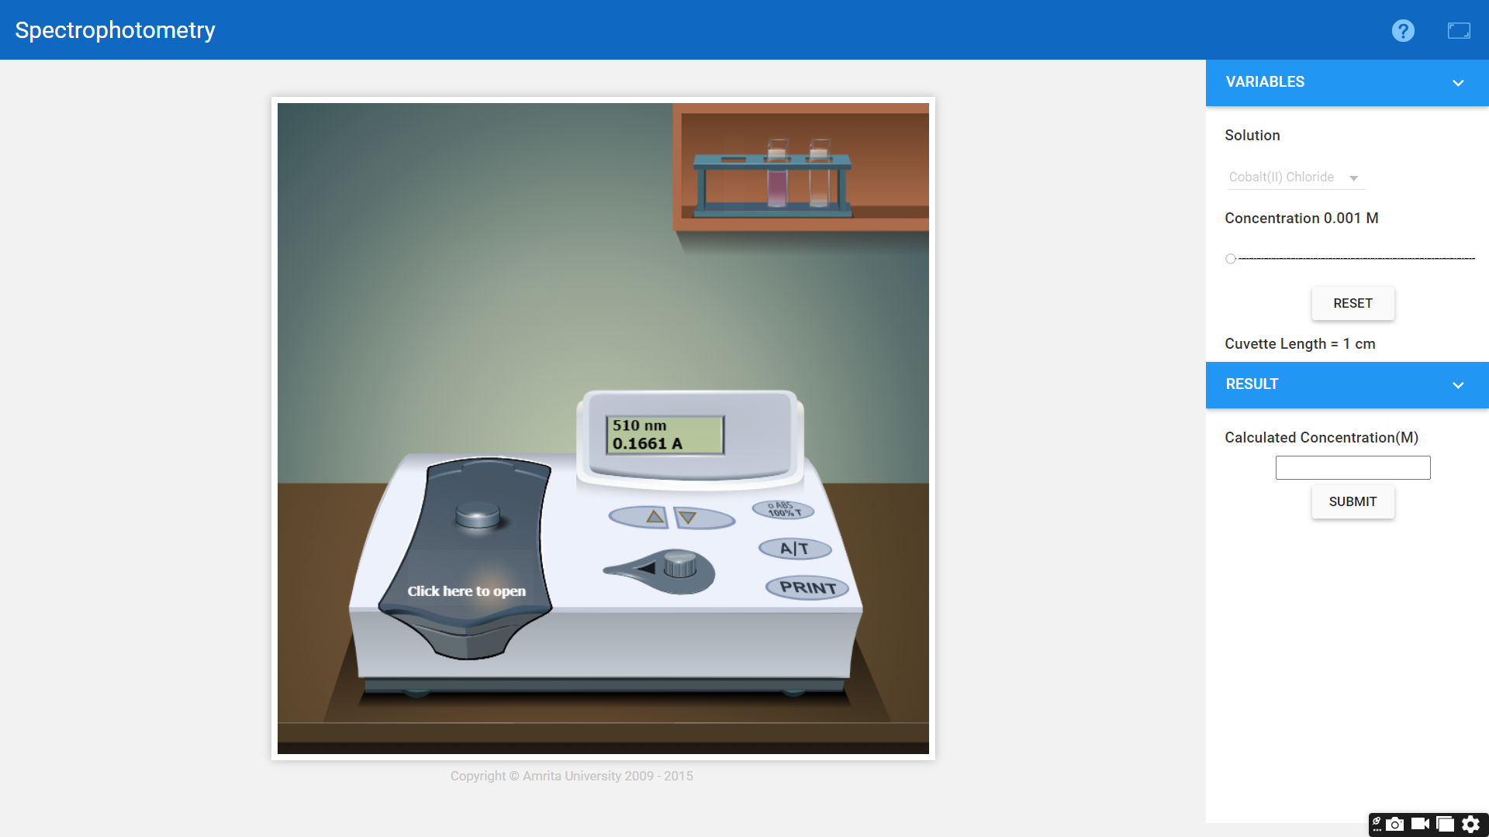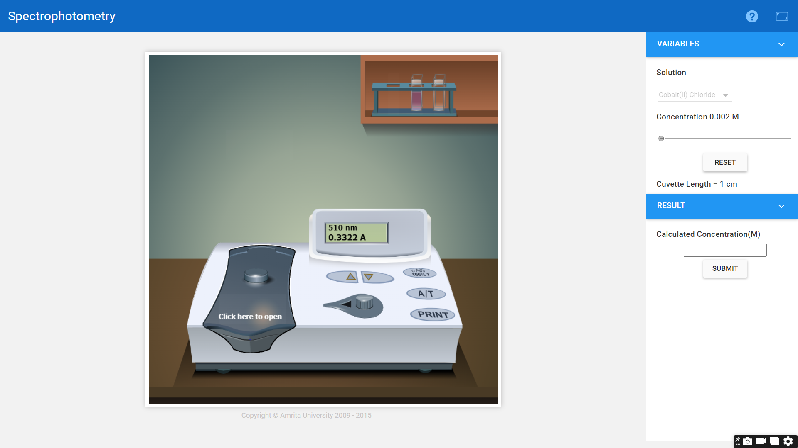

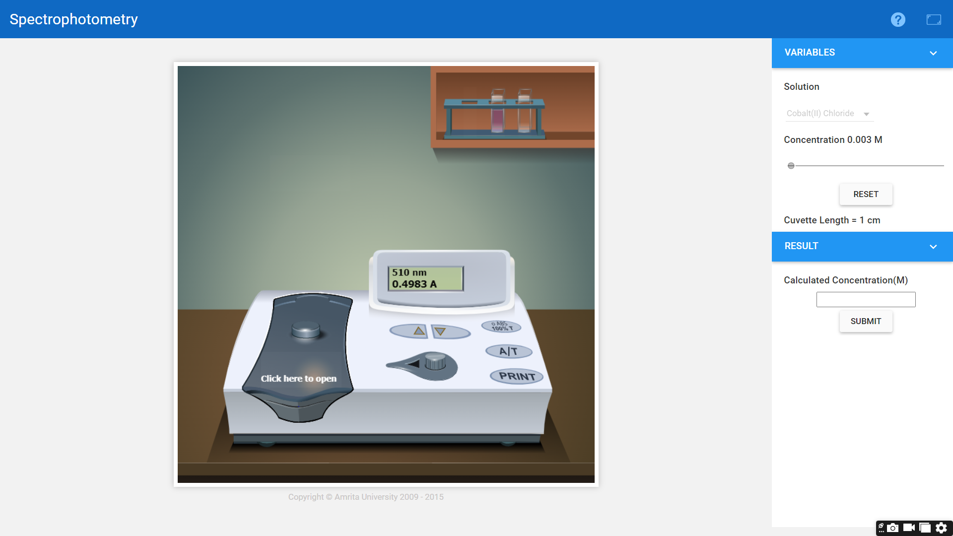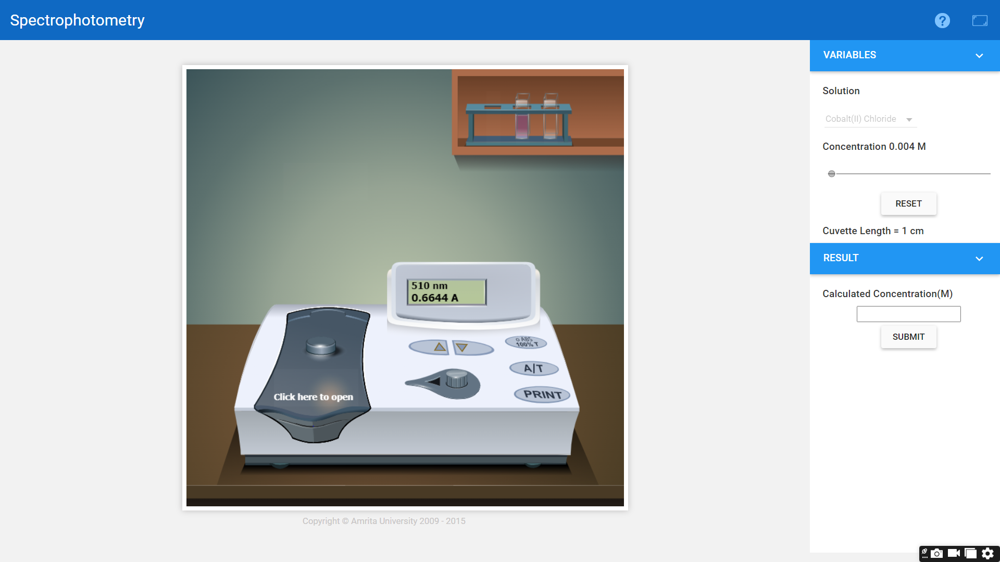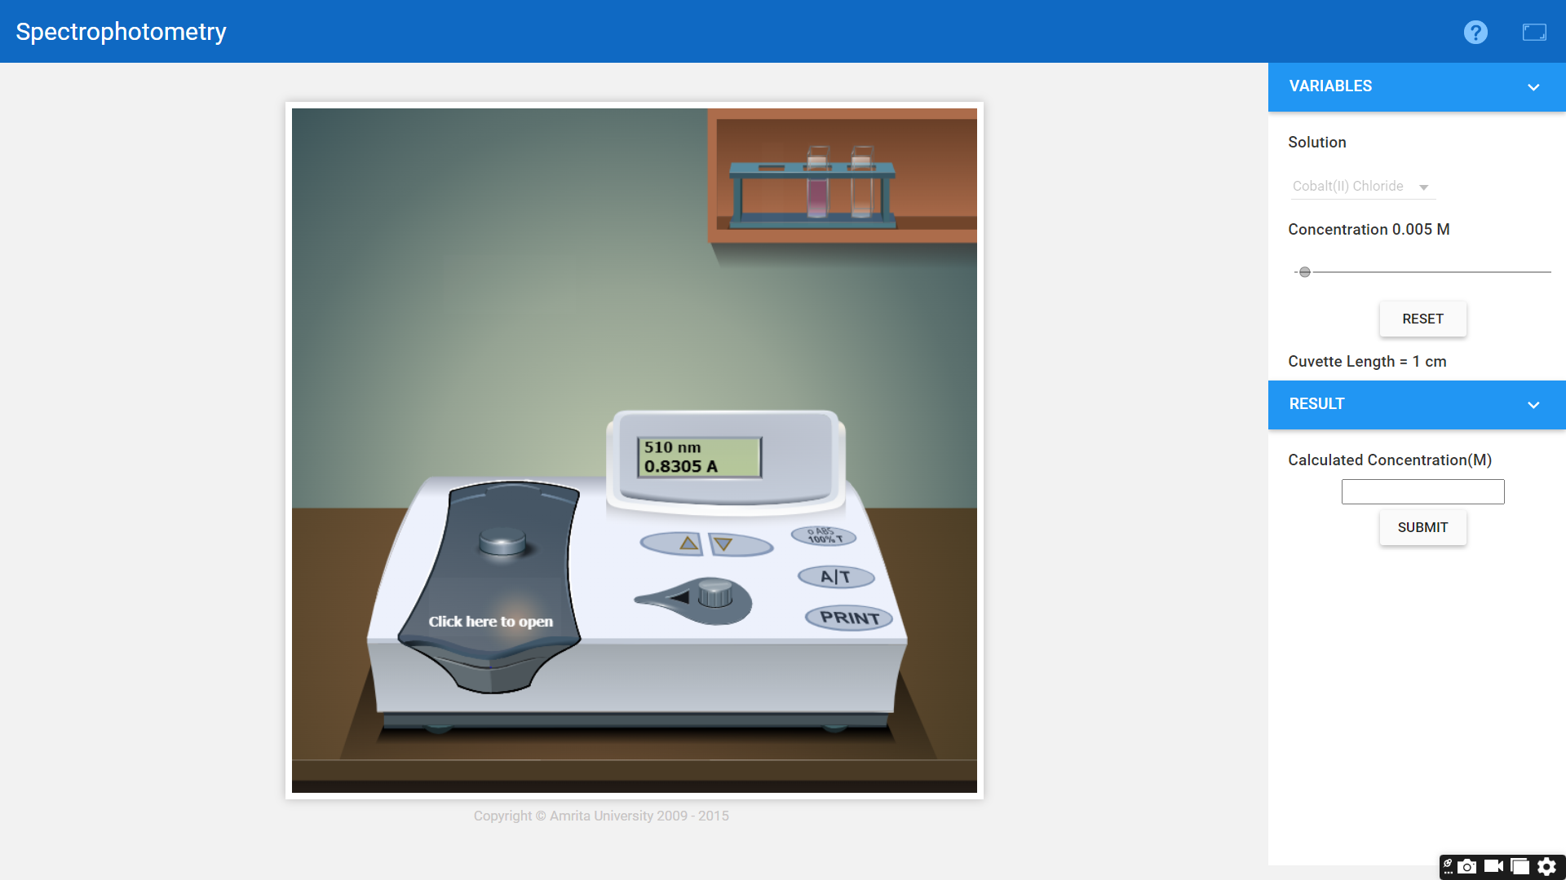

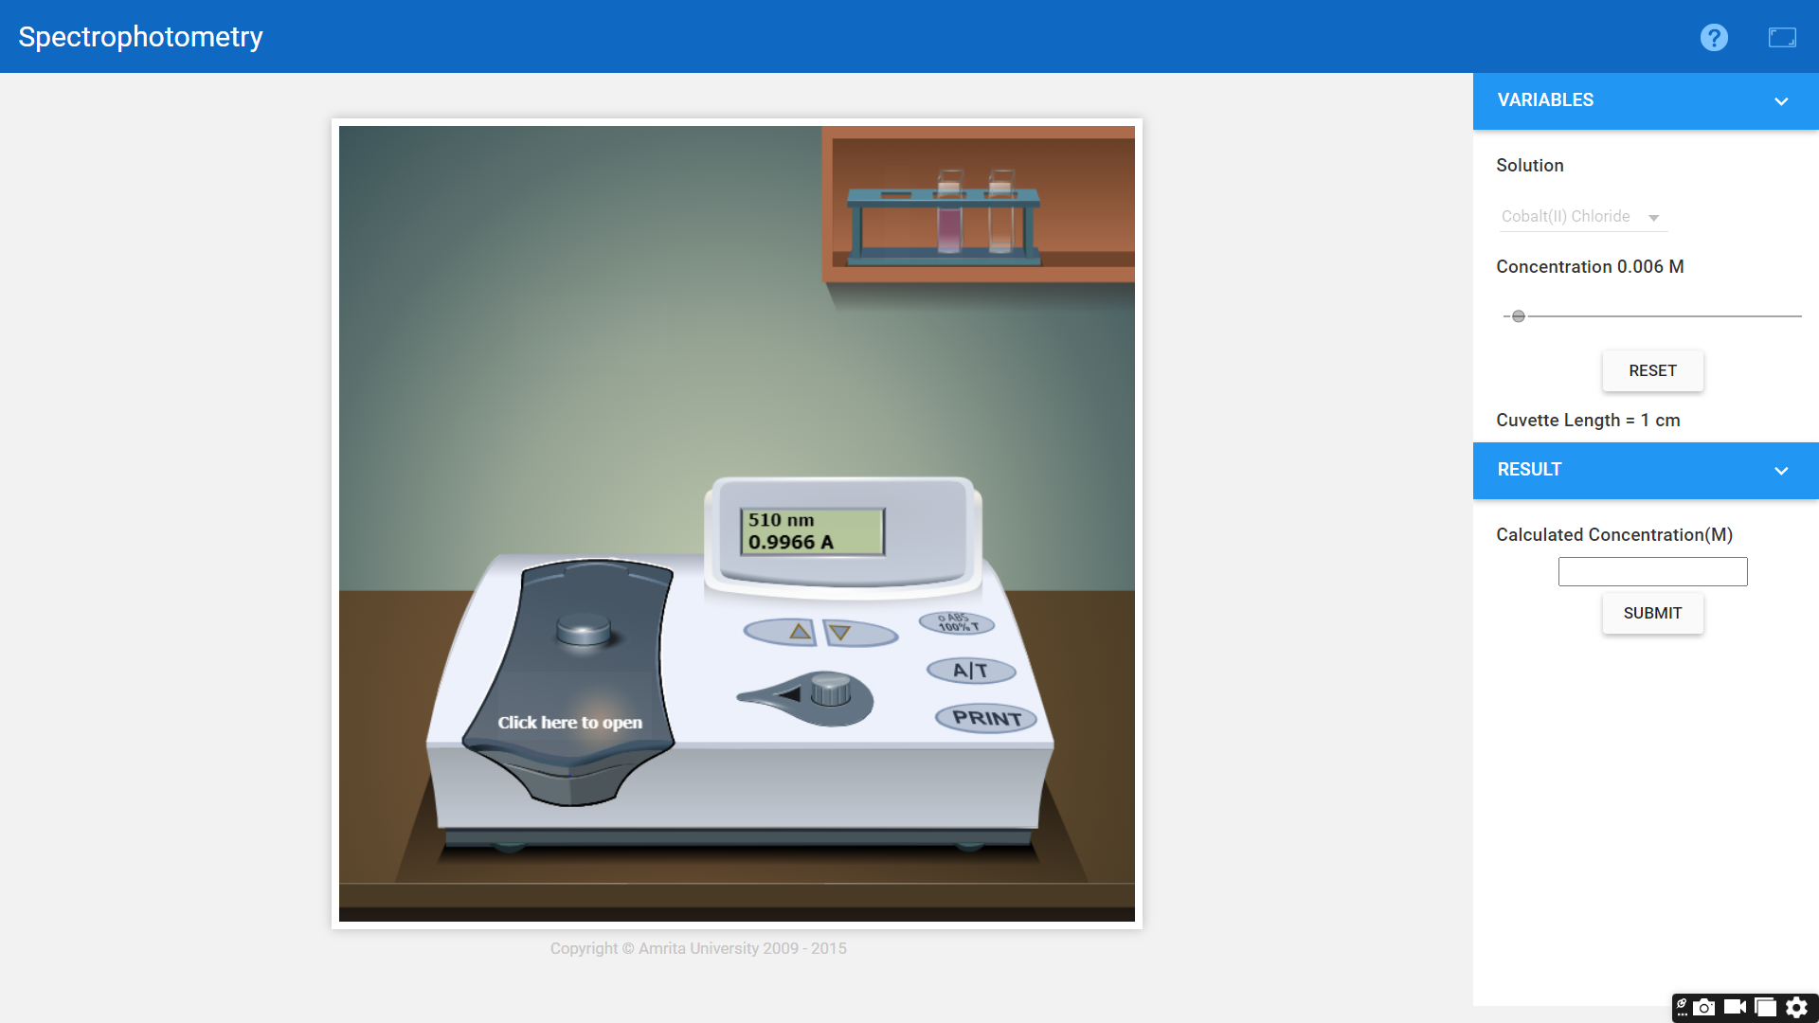

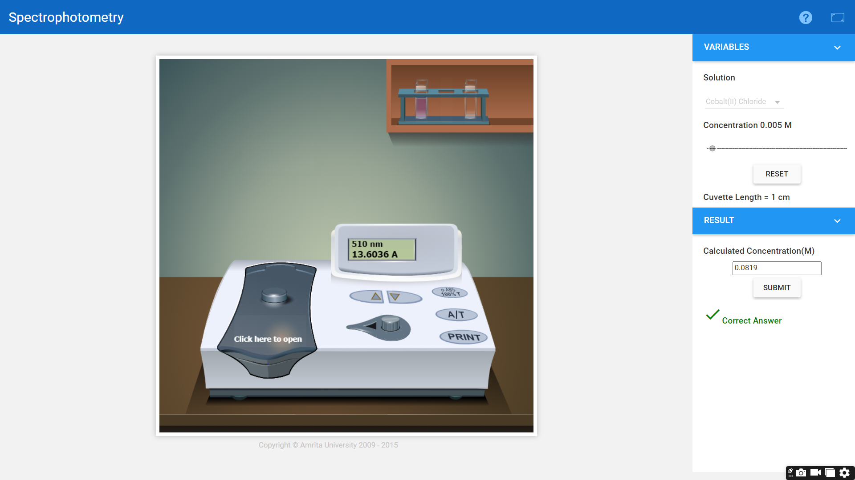

**Graph:** (Absorbance v/s Concentration)

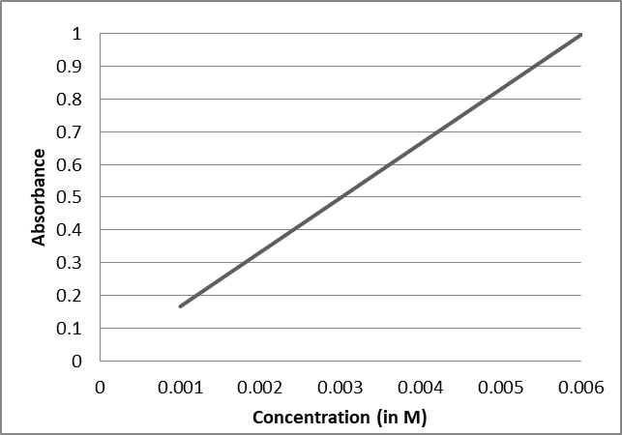

**Calculations:**

The molar absorption coefficient ε was calculated for all absorbance maxima of the test substance. The formula for this calculation is

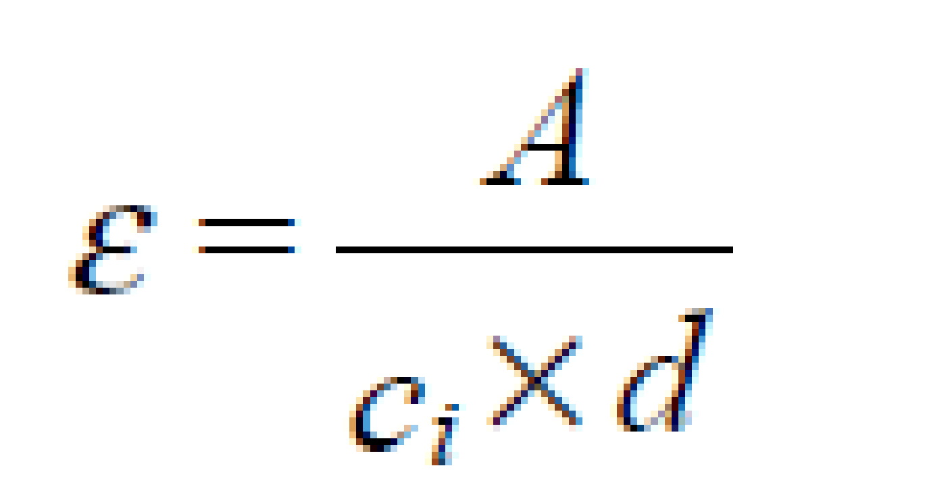

Where:

A = Absorbance of sample,

ci = concentration of sample(known),

d = cell path length.

Let the concentration of sample(unknown) be ;

Using graphical method,

Slope of the graph

**Result:**

1. Concentration of unknown (by calculation) = 0.0819 M

2. Slope of the graph = 166.1

3. Concentration of unknown (from graph) = 0.0819 M